Job Aid: Calculating Supplies⁴⁰³

An efficient procurement management system will provide the amount of required supplies to fulfill needs without waste due to the expiration of unused supplies.
(f) The calculation takes into account your reorder level and includes a reserve quantity. To avoid wastage from expired reagents, the calculation subtracts the available stock you currently have on hand.

Key Terms and Concepts:
(a) Determine the average number of patients, survey samples, and QC performed for a month. To obtain an average, review several month’s worth of tally data to reflect an accurate testing volume. Many sites will include a 10% wastage factor to accommodate repeat testing, training or competency assessments. However, by including column (c) as a reserve quantity into the equation used to calculate column (f) that may not be necessary. If testing volume fluctuates for specific time periods throughout the year, then adjust the average.
Lead Time – time between placing an order and receiving it.
Average Usage - number of test kits, reagents or supplies used in a given time period.
Minimum Stock -amount of stock required to support testing operations until additional supplies are received.
(g) Catalogs and order requisitions can be used as a resource to determine the vendor’s amount. For example, if you list a test kit as an essential supply and the test kit accommodates 20 individual tests, then the amount is 20 tests per kit. Likewise, if you indicated 3 ml of a stain is required for each test in column b for AFB testing and the stain comes in a liter bottle, then the amount is 1000ml per bottle. Ensure proper units are used to calculate the correct orderable amount.
Reorder Level - the minimum stock level at which you should reorder the item and the amount you should reorder.
Reordering Equation - Average Usage x Lead Time = Minimum Stock (Reorder Level).
(b) Determine the amount of supply needed to perform one procedure.
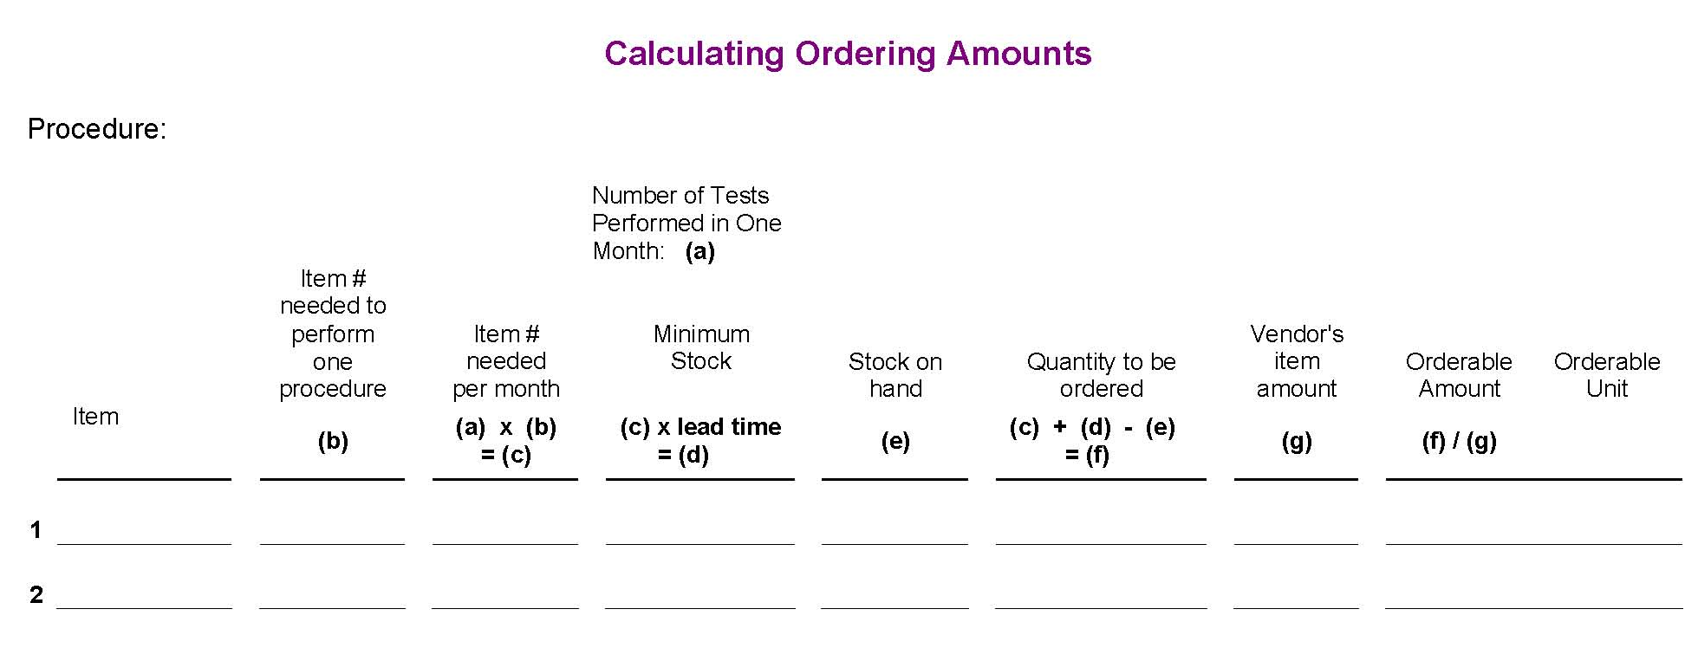
List the essential supplies required to perform the test.
(c) This is the average usage for the month for test kits, reagents or supplies. This amount will also be used as the reserve quantity.
(d) This is the minimum stock you must have on hand to support testing until additional supplies are received. When this quantity is reached, you must reorder. You will not sustain testing services for this procedure if you go below this quantity. Lead times may vary for different vendors. Review your previous ordering/receiving history to determine the lead time.
(e) You determine the stock you have on hand by performing a physical stock count, physically counting the available supplies. The available stock should never run below the minimum stock level. To determine the correct quantity, the stockroom must be organized and maintained. The inventory records must be current.

(f) / (g) Always round up to the nearest whole number. This number is the amount to indicate on the ordering requisition for the specific catalog number or description.

